

Internet and Web Programming (CS 536P)

Mini Project Report

on

Health Check-Nutrifit

Submitted in partial fulfilment of Continuous Internal Assessment of

Internet and Web Programming CS536P

Computer Science and Engineering

by

Abin Aju (1860301),

Christa Mathew (1860387),

Liyans Mathews (1860392)

Under the Guidance of

Dr R. Sathish Kumar

Department of Computer Science and Engineering School of Engineering, CHRIST (Deemed to be University), Kumbalgodu, Bangalore - 560 074

November - 2020



Faculty of Engineering

Department of Computer Science and Engineering

CERTIFICATE

This is to certify that Abin Aju (1860301), Christa Mathew (1860387), Liyans Mathews (1860392) successfully completed the project work entitled Health Check- Nutrifit in partial fulfilment for submission Internal Assessment of Mini Project in Internet Web Programming(CS536P) 2020-2021.

Dr Rekha V Dr R. Sathish Kumar

Staff Coordinator Project Guide

Dr K Balachandran Dr Iven Jose

Head of the Department Dean



Acknowledgement

We would like to thank CHRIST (Deemed to be University) Vice Chancellor, Dr Rev. Fr Abraham V M, Pro Vice Chancellor, Dr Rev. Fr Joseph C C, Director of Faculty of Engineering, Dr Rev. Fr Benny Thomas and the Dean Dr Iven Jose for their kind patronage.

We would like to express my sincere gratitude and appreciation to the Head of the Department of Department of Computer Science and Engineering, Faculty of Engineering Dr K Balachandran, for giving me this opportunity to take up this project.

We are also extremely grateful to my Staff Coordinator, Dr Rekha V, Assistant professor, Department of CSE who has supported and helped to carry out the project. Her constant monitoring and encouragement helped me keep up to the project schedule.

We are also extremely grateful to my Dr R. Sathish Kumar, Assistant professor, Department of CSE, who has supported and helped to carry out the project. His constant monitoring and encouragement helped me keep up to the project schedule.

We also thank all the faculty members for their continuous support and constructive inputs that have helped shape this project. This project would not be complete if it were not for the variety of ideas put forward by my classmates and peers. Last, but not the least we thank our parents for being a support in all challenges we faced during this project.

Abstract

Health Check website- Nutrifit is a user friendly website which has various features that helps an individual to stay fit and healthy.

It aims to provide quality healthcare, nutrition, online consultation and an exercise regimen. Healthcare is a necessity and Nutrifit has various features that helps an individual to take care of his/her health on a regular basis.

The diet chart feature helps an individual to plan the diet according to his/her requirements, the basic detail page allows a user to enter details like height weight and allows the user to have a fair idea about any disease that he/she has on the basis of that they can book an appointment and use the consultation service, the workout at home feature helps an individual to plan his/her exercise regime and the online specialist consultation facility helps an individual to check various specialist consultation features and book an appointment.

Contents

Certificate

Acknowledgement

Abstract

1. Introduction
2. Implementation
3. Snapshots
4. Discussions
5. Conclusion
6. Scope for Future work
7. Bibliography

INTRODUCTION

Staying healthy and fit is necessary for an individual to do his/her daily work in the best way possible and in this era it is not an easy goal to achieve due to the busy schedule that most of us have.Therefore, a website such as Nutrifit helps an individual in taking good care of his/her health in an orderly way.

Nutrifit has  features such as diet chart, basic detail, exercise regime, and online consultation. All these features help an individual to lead a healthy life in an orderly way.

It helps an individual to plan the diet according to his/her requirements,it also includes diet chart to be followed for different chronic diseases,the basic detail page helps in finding out the disease you are suffering from on the basis of your symptoms, the exercise regime helps an individual stay healthy by following  different exercises and online consultation feature helps in having a hassle free appointment booking and consultation.

1.1 Problem Formulation

It is not easy to have a healthy lifestyle due to the busy schedule that everyone has. Keeping this in mind our team has created a user-friendly Health Check Website-Nutrifit that will help its users to maintain a healthy lifestyle at the comfort of their home.

1.2 Problem Identification

 It is necessary to have a healthy lifestyle to avoid the risk of various diseases and it is not an easy goal to achieve without proper guidance and support. It is necessary to have knowledge about the proper diet intake, exercise regimen to be followed and to have consultation service at the comfort of one's home. All of these are neglected by people due to the busy lifestyle that they have but these  are imperative for an individuals well being.

1.3 Problem Statement and Objectives

It is not easy to have a healthy lifestyle without having an integrated service of the different necessary features and  thus  it is necessary to integrate all the different features(diet plan, exercise regimen and consultation service) into a single platform so that the users can lead a healthy lifestyle without any difficulty.

To ensure the same we have the following features in our website-

* Workout videos by experts
* Diet Charts for specific diseases
* Online consultation and appointment booking services

1.4 Limitations

* There is a greater chance of miscommunication between client and therapist. Therapists cannot as easily access body language information (even when using video chat). Counsellors are therefore at a greater risk of missing important non-verbal cues.
* Insurance companies rarely cover the costs of online counselling.
* Medication cannot be prescribed after an online counselling session.
* An unreliable internet connection may interrupt the flow and delivery of the therapy.

2. IMPLEMENTATION

This project was made using HTML, CSS and javascript for the front end and XAMPP with phpmyadmin(mysql) for the back end.

We have the following modules in our website-

* Welcome page
* About us
* Login
* Diet Chart
* Health Check
* Workout at Home
* Online Consultation

The user needs to login to enter the website. If the credentials entered by the user do not match with the data in our database, access will be denied. New users can register and create a new account to login and avail our services. The website has diet charts for specific diseases and also fitness videos by experts through which one can easily do workouts at home. The highlight of our website is the online consultation service. The users can book their appointments and make the necessary payment in order to have a consultation at the comfort of their homes.

3.         SNAPSHOTS

**Front End**

Welcome Page

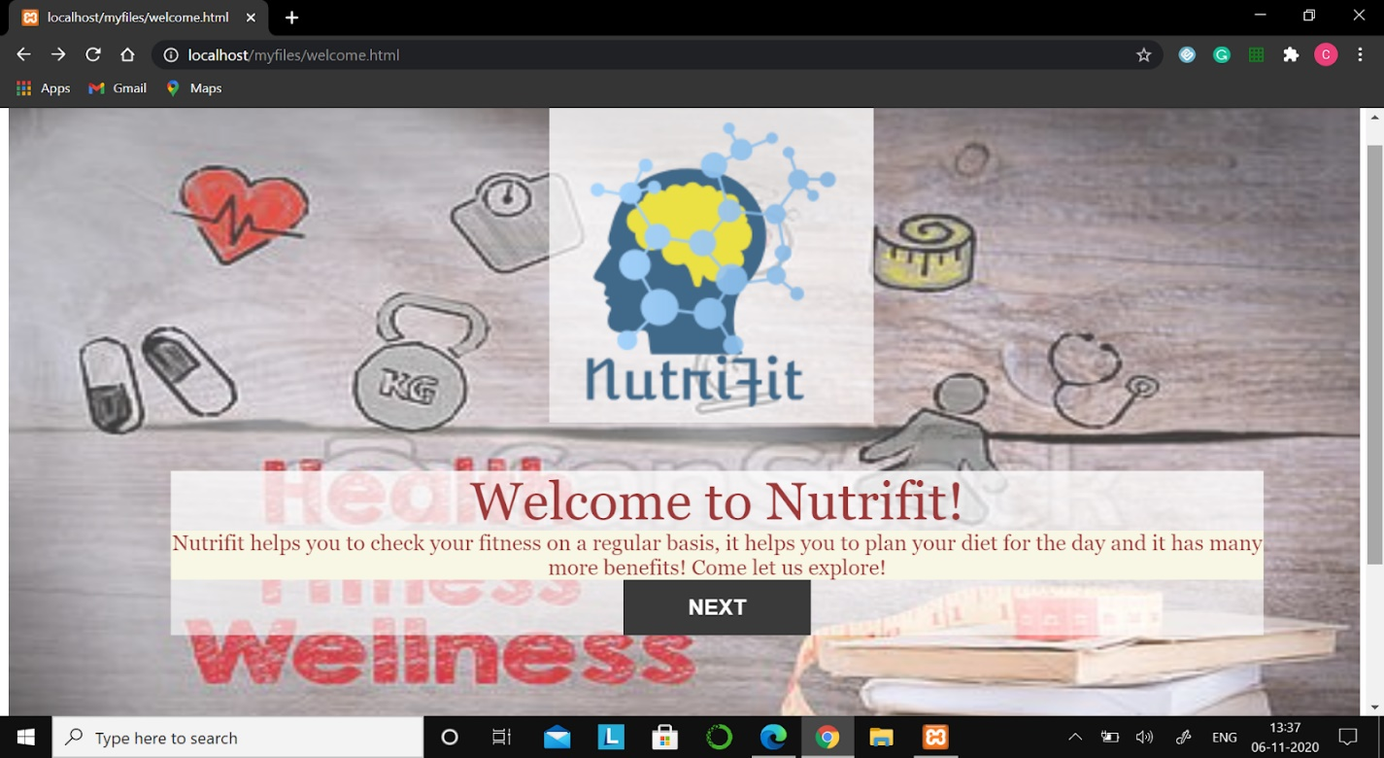

Login Page

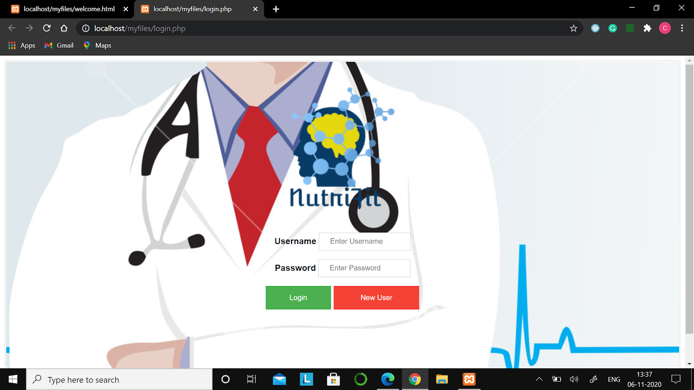

New User Registration Page

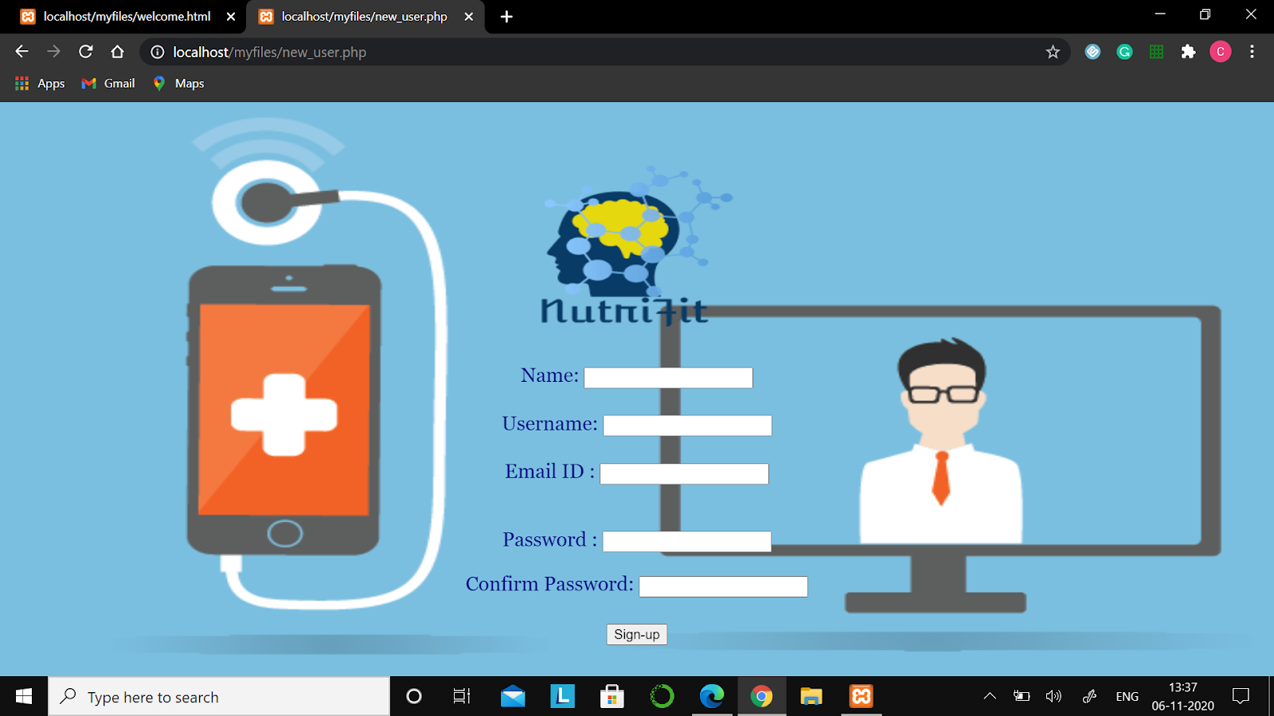

About Us Page

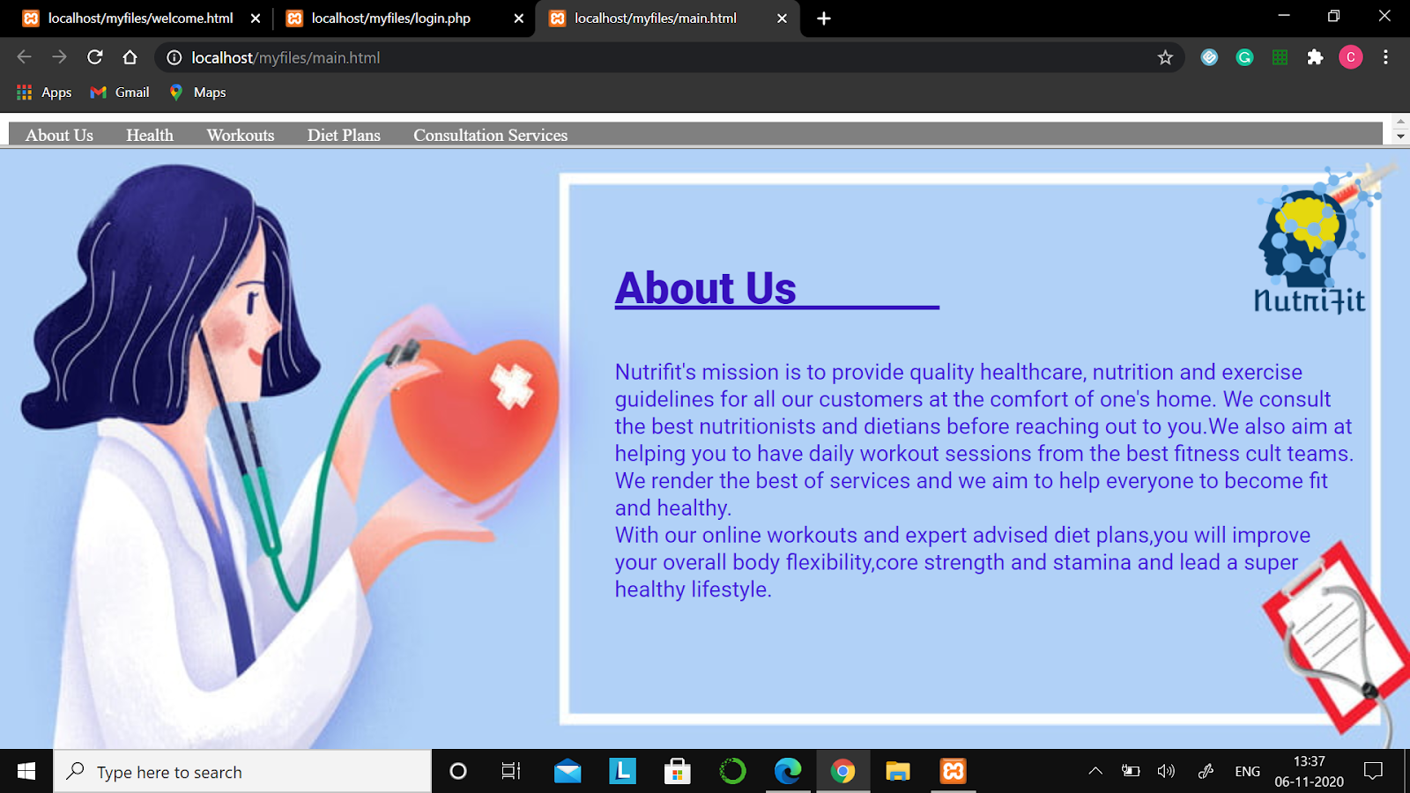

Diet Plans

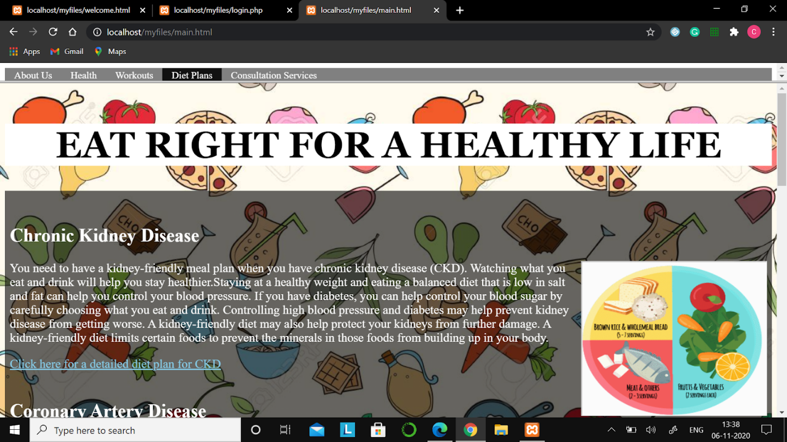

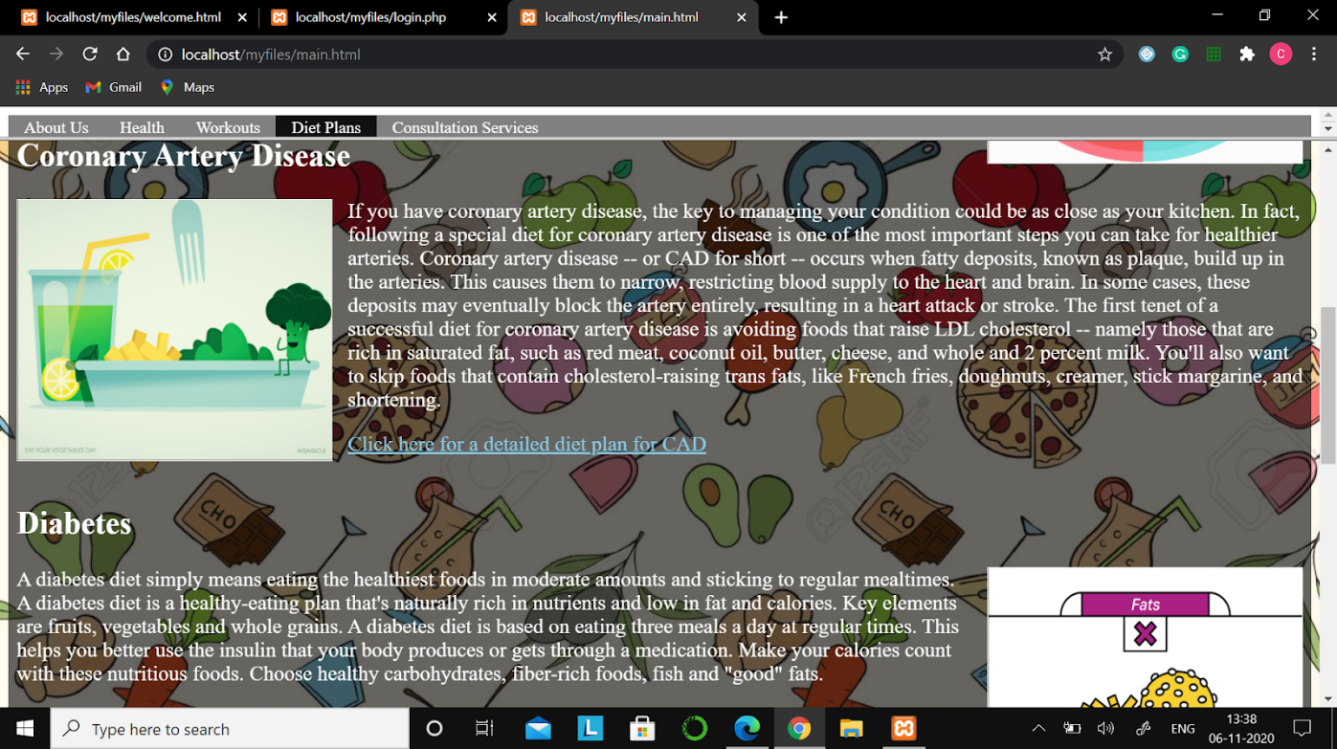

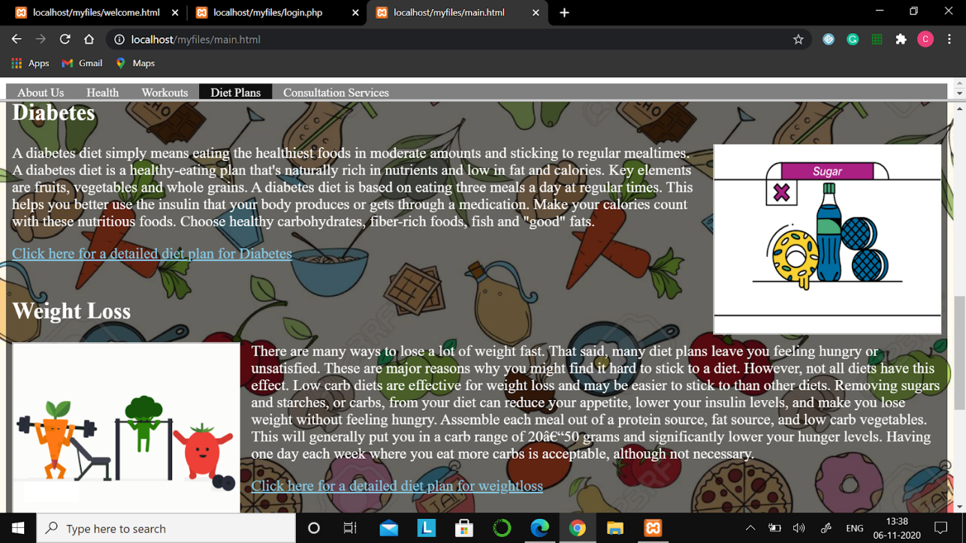

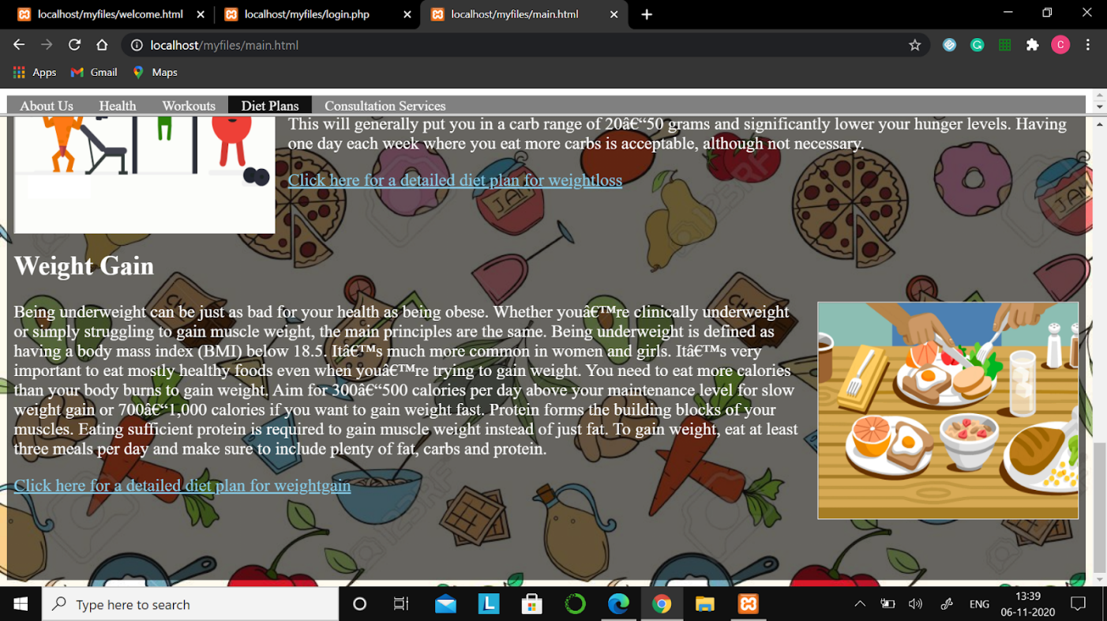

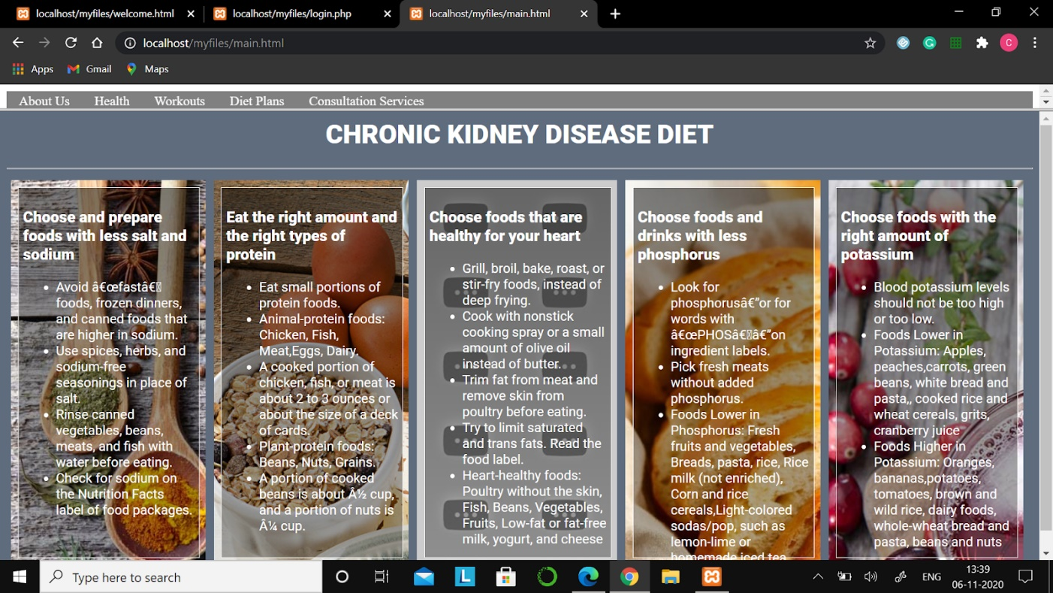

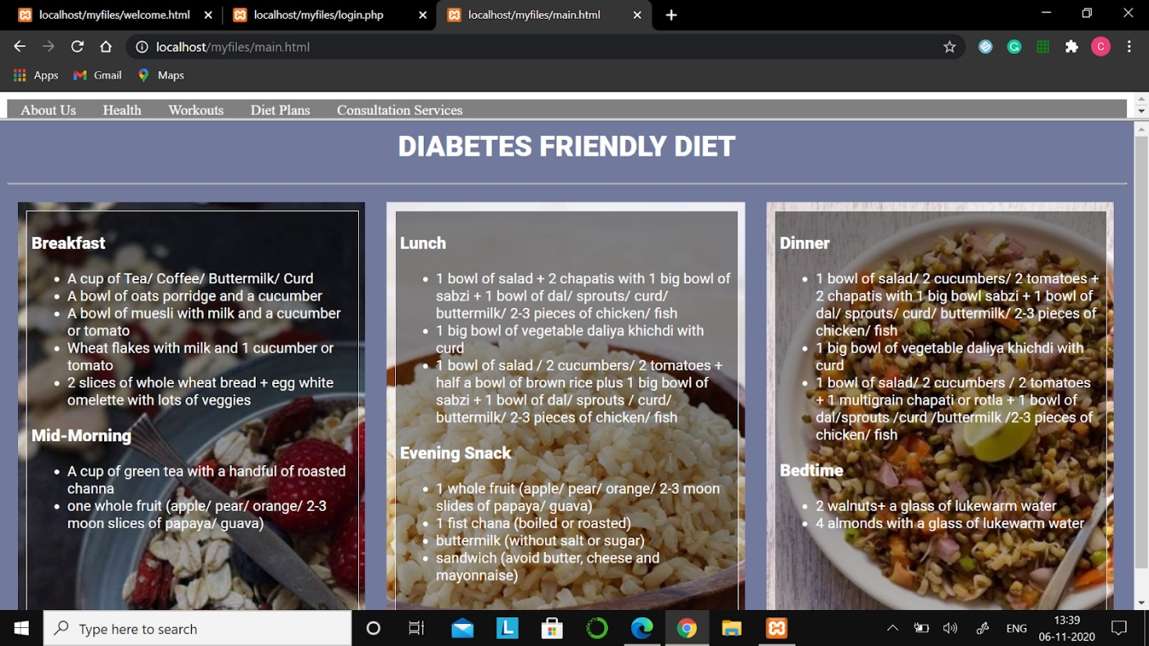

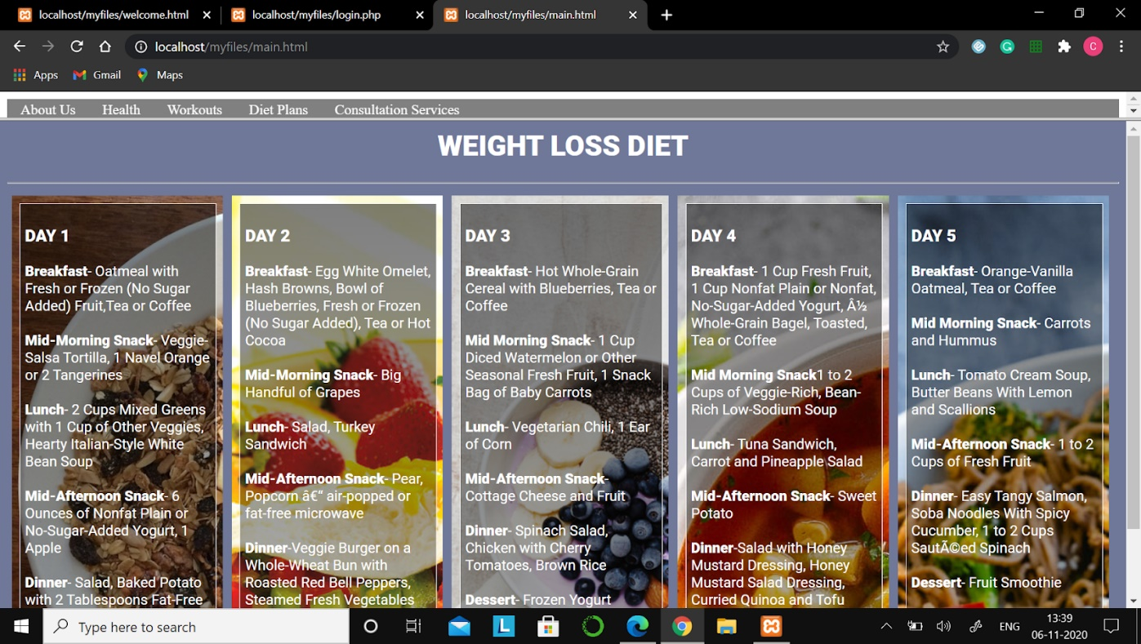

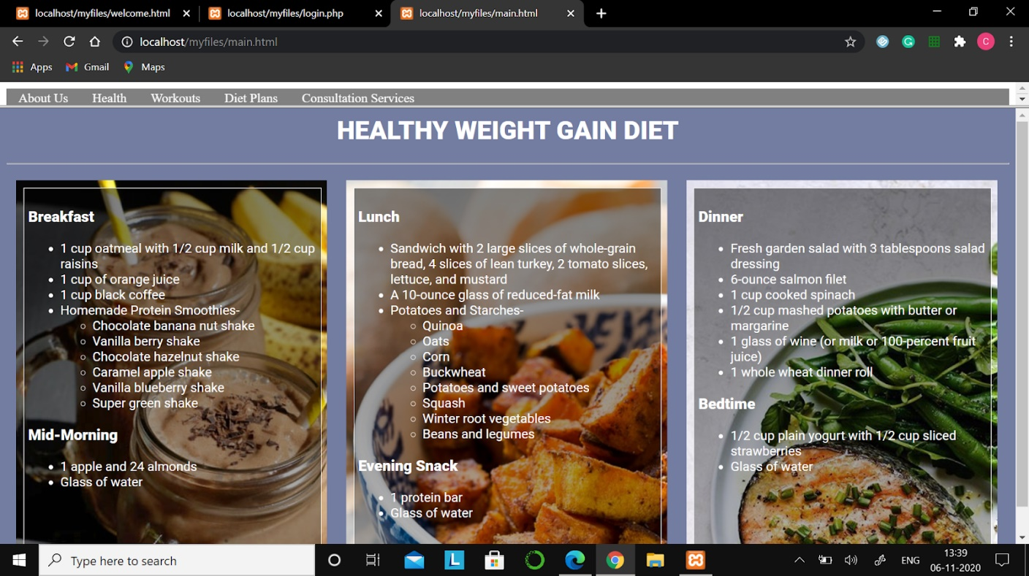

Workout At Home

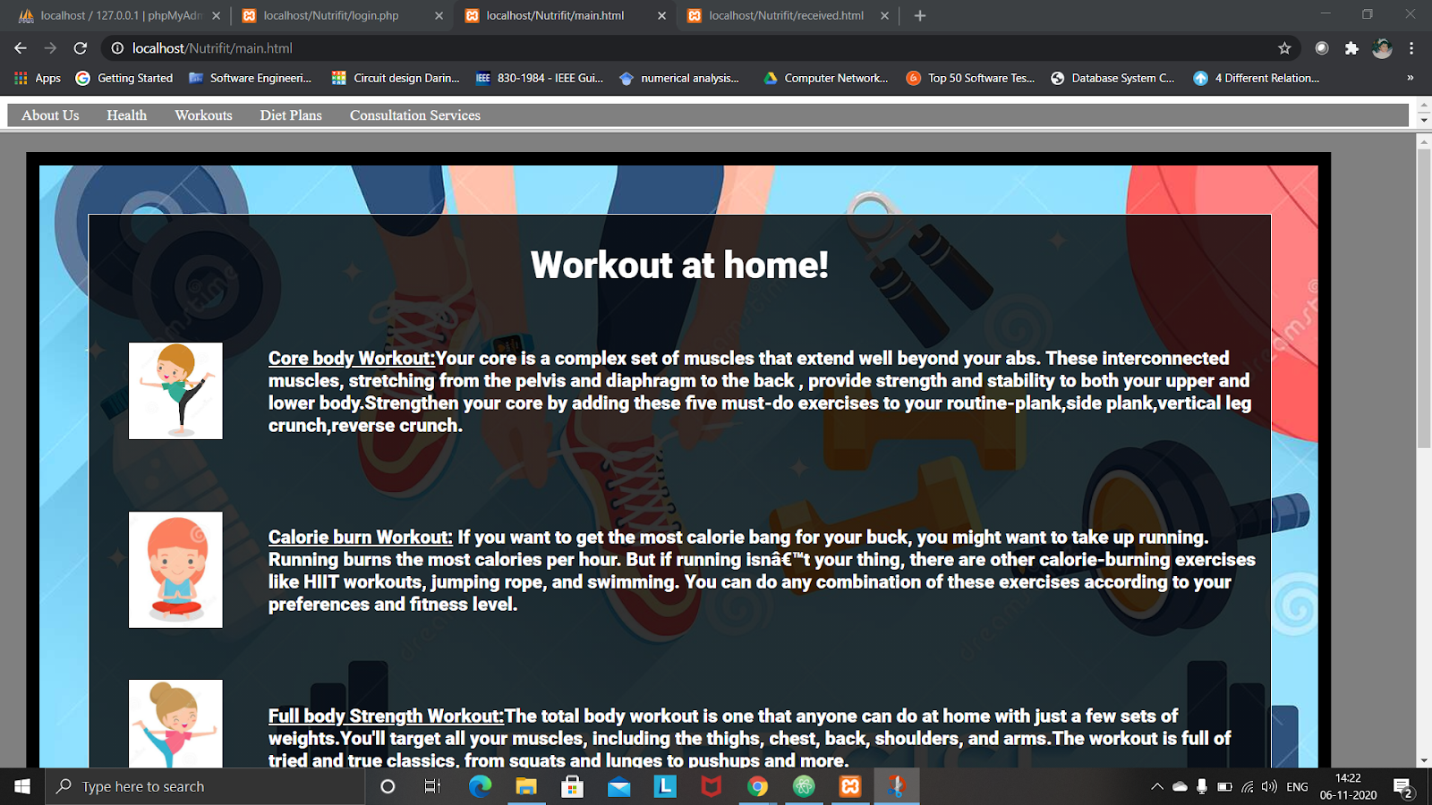

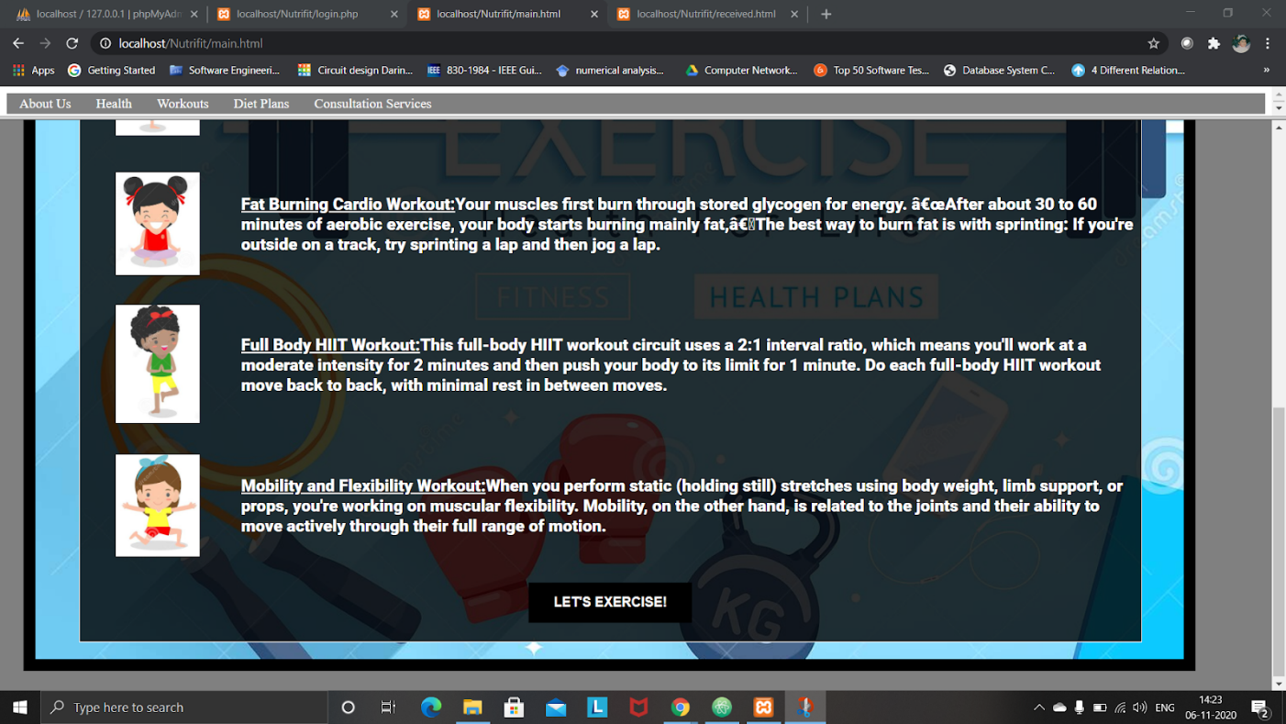

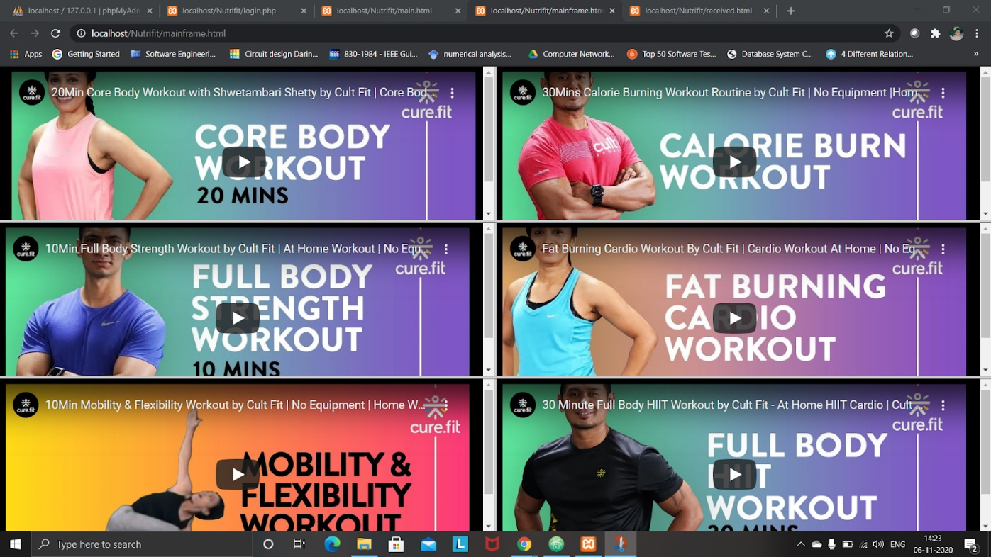

Consultation Services

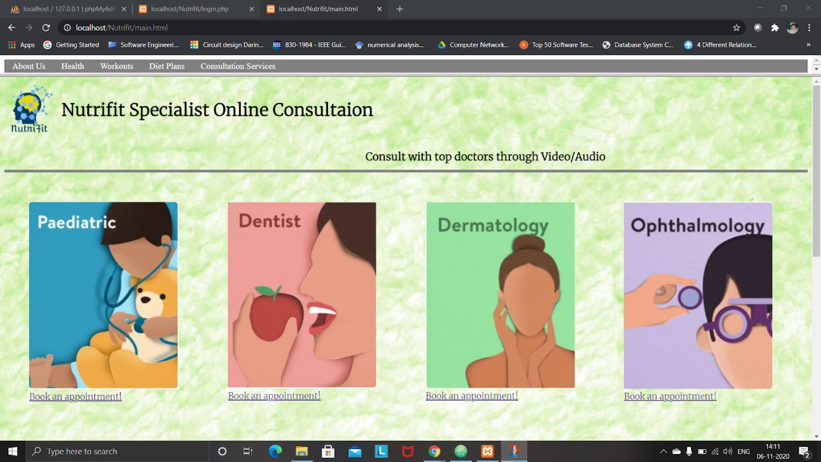

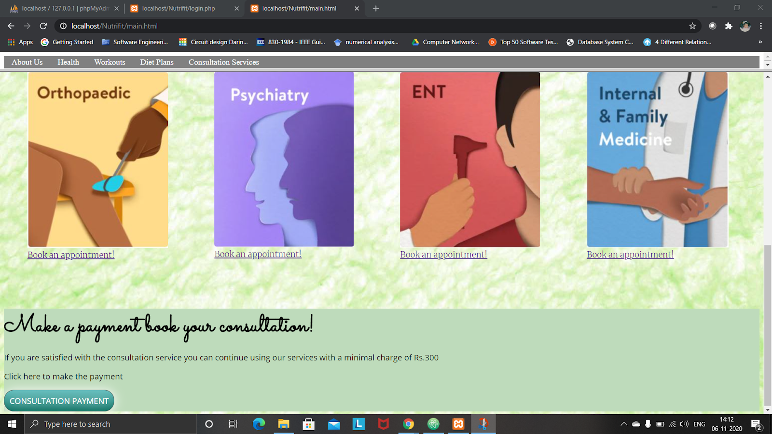

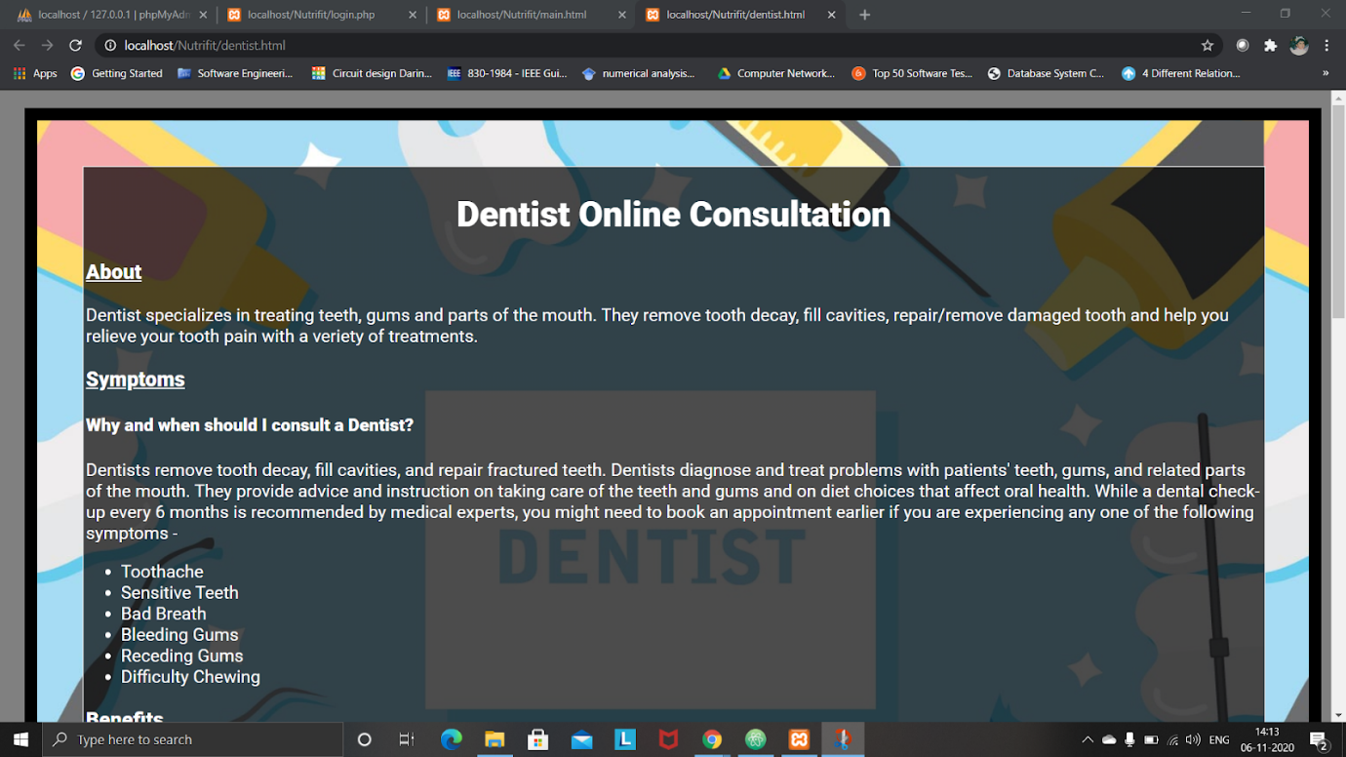

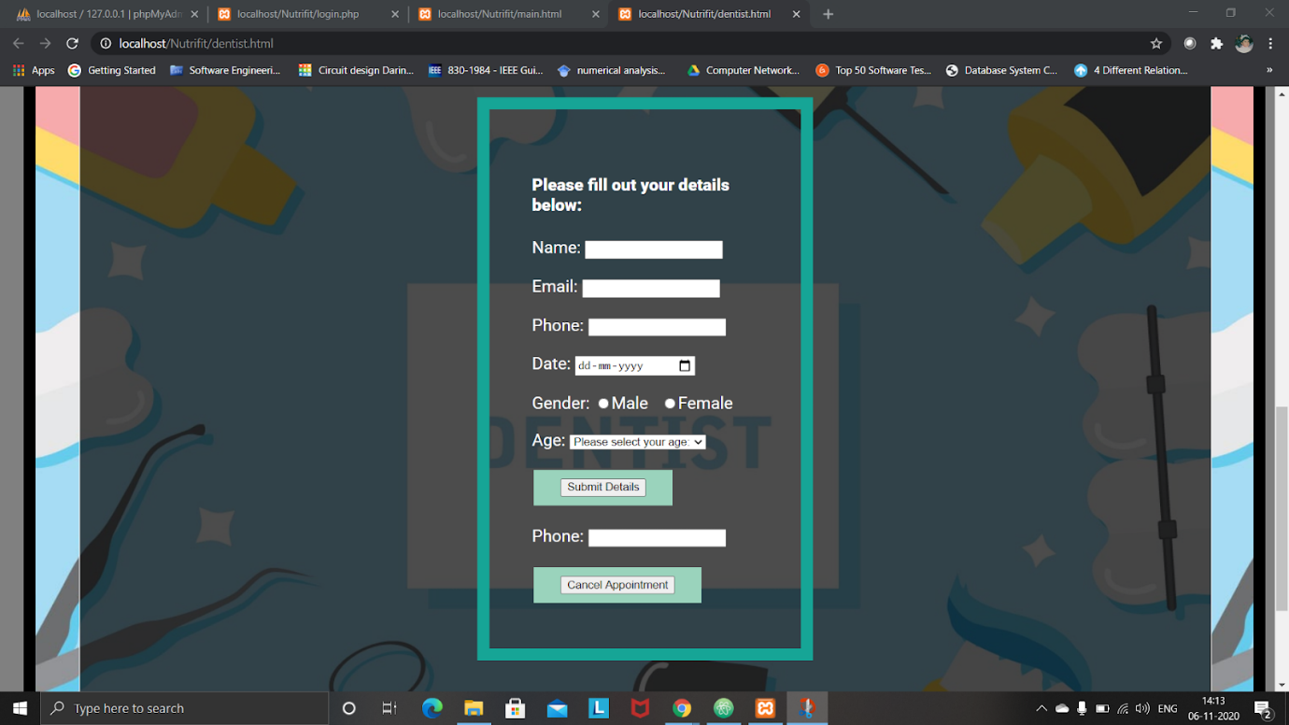

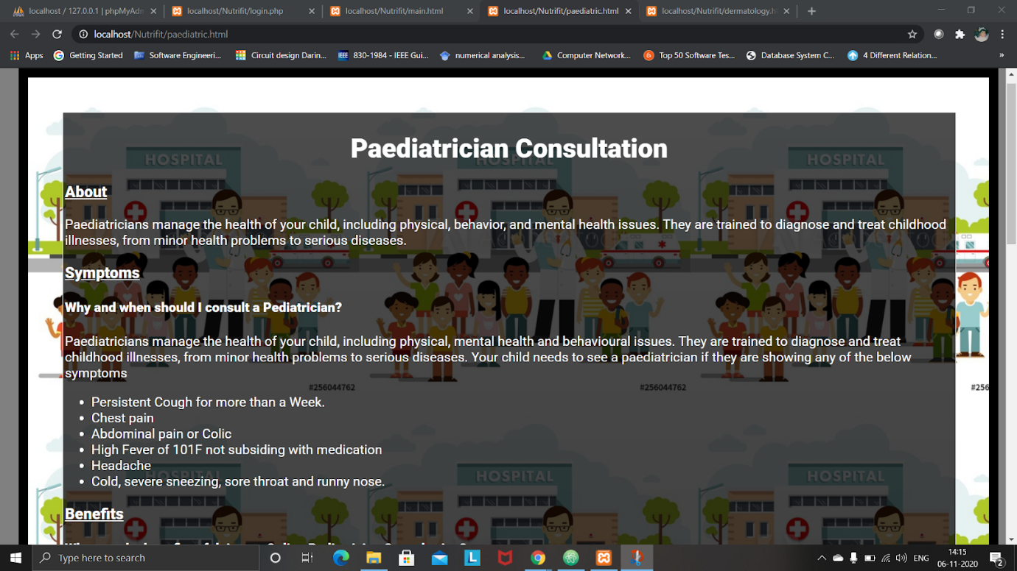

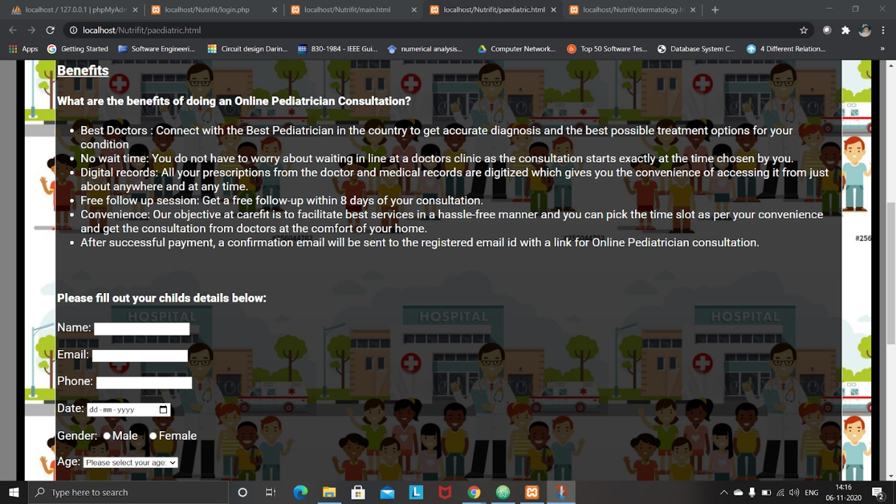

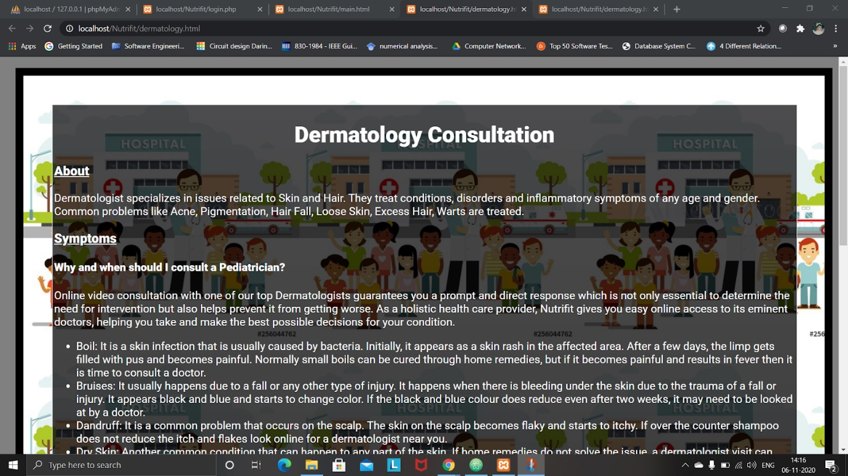

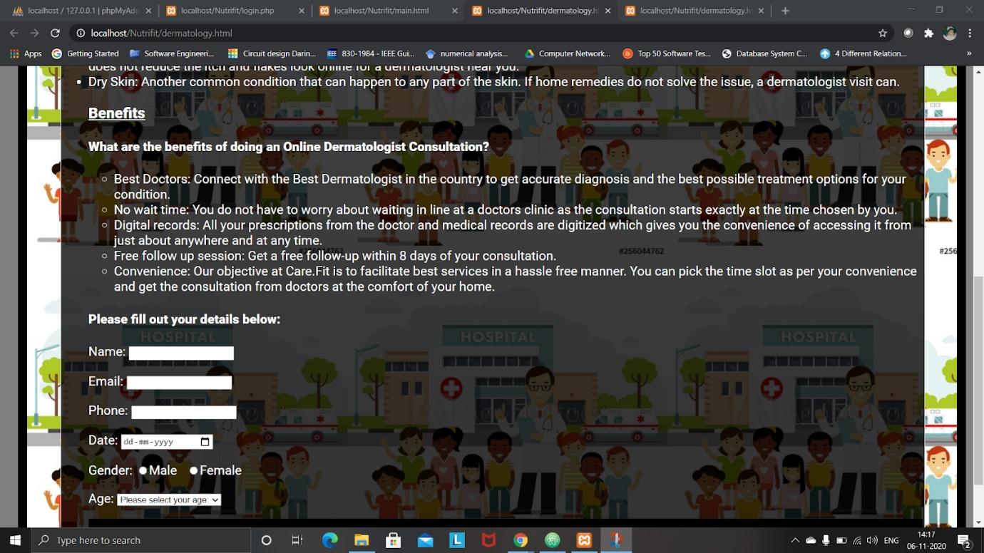

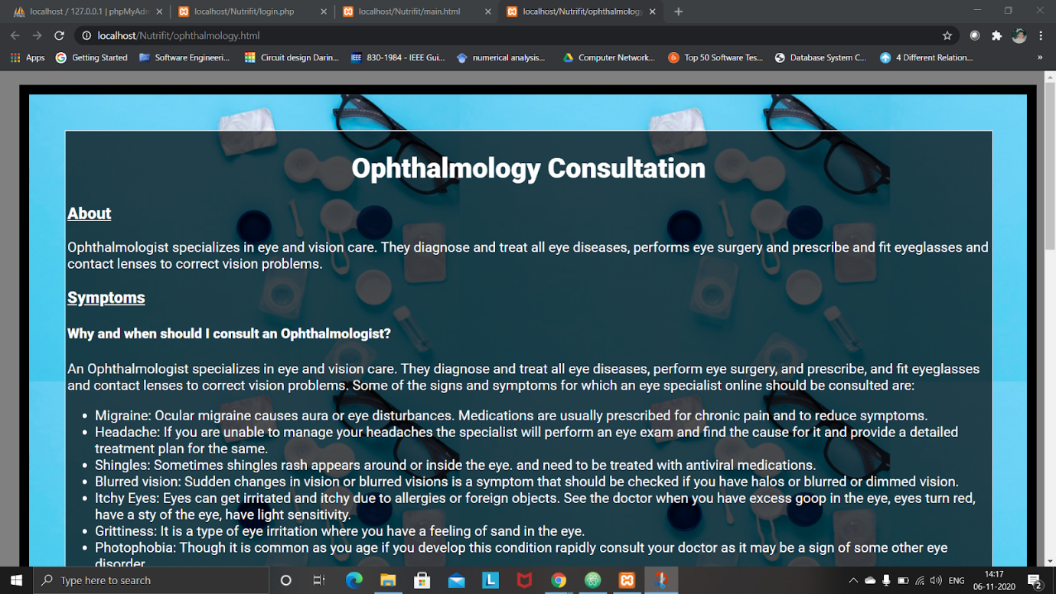

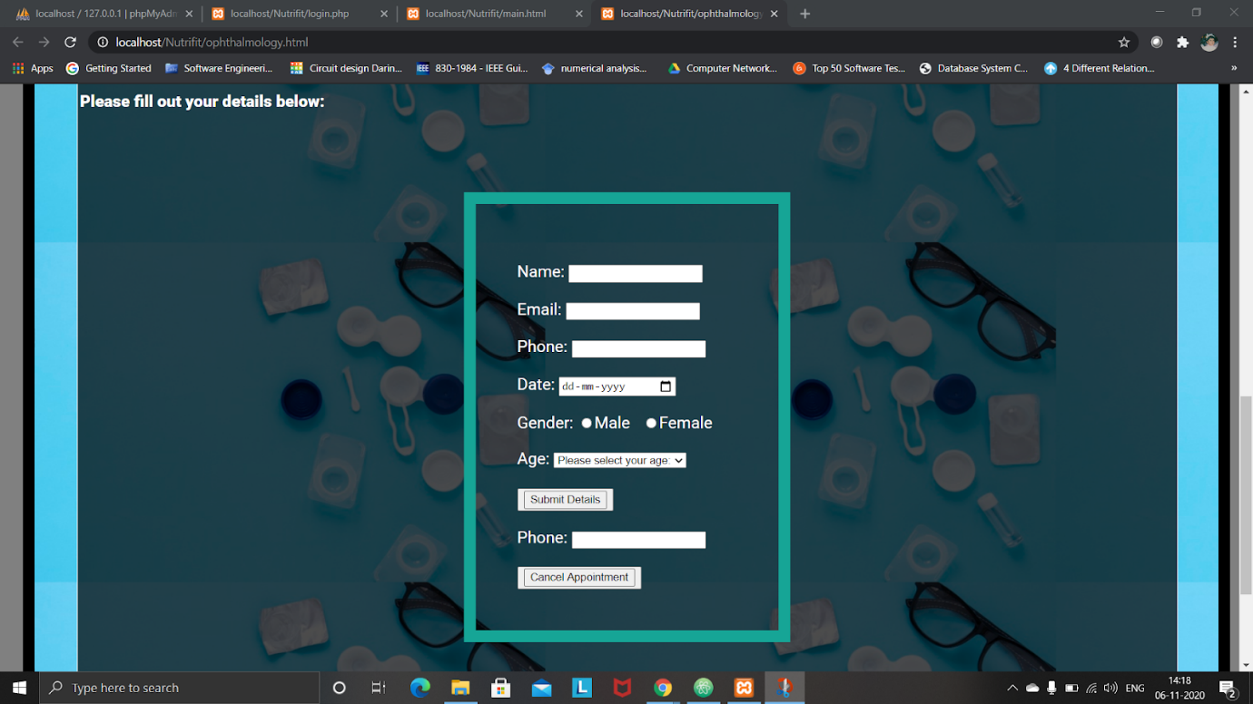

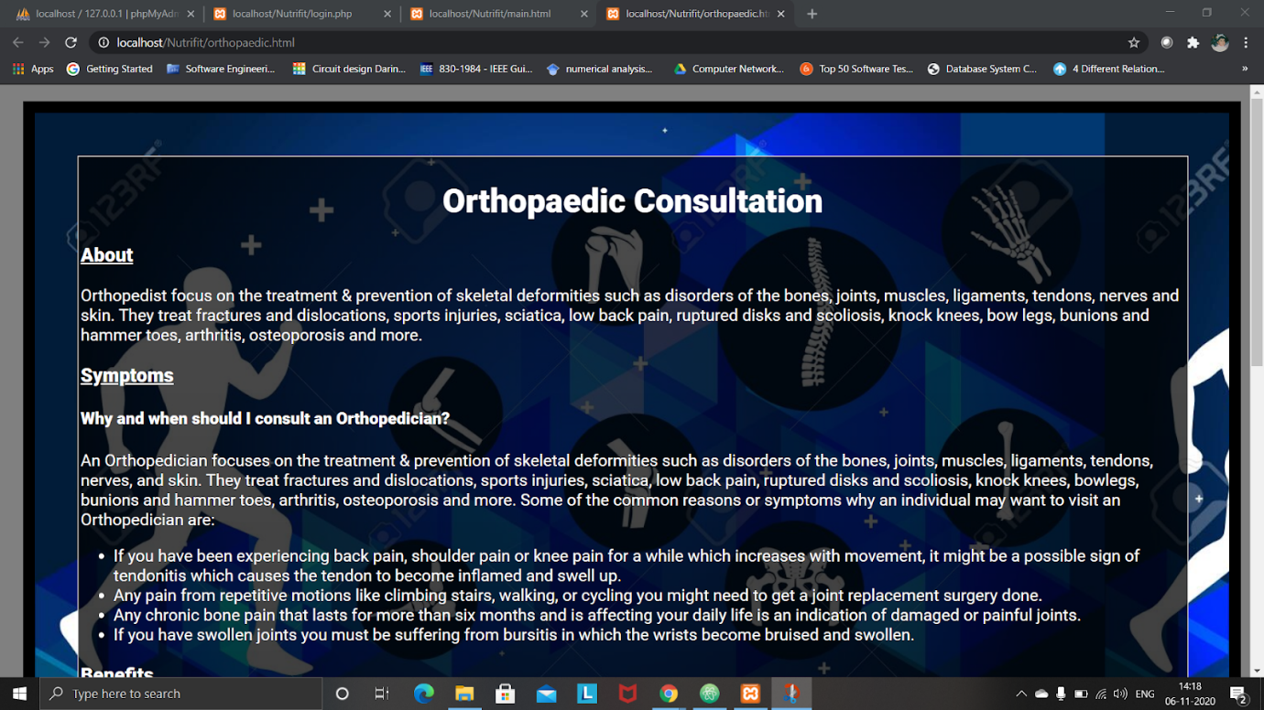

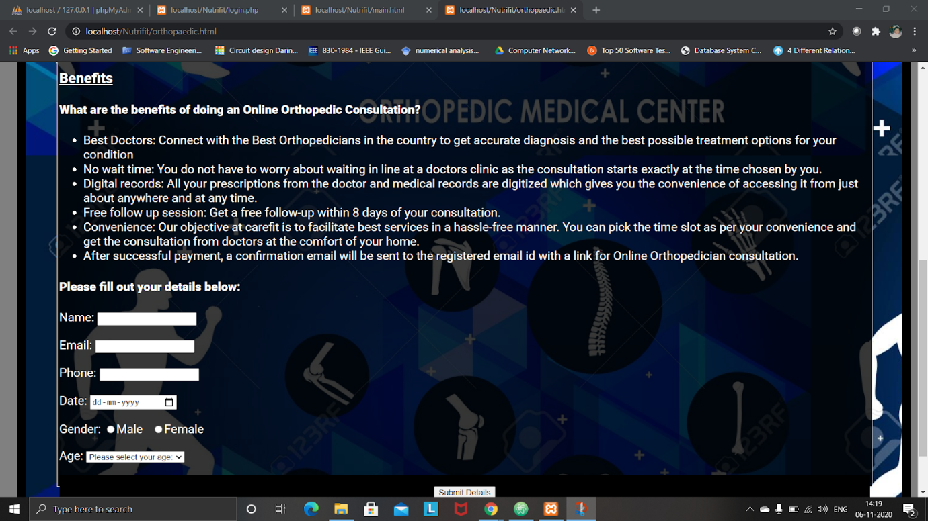

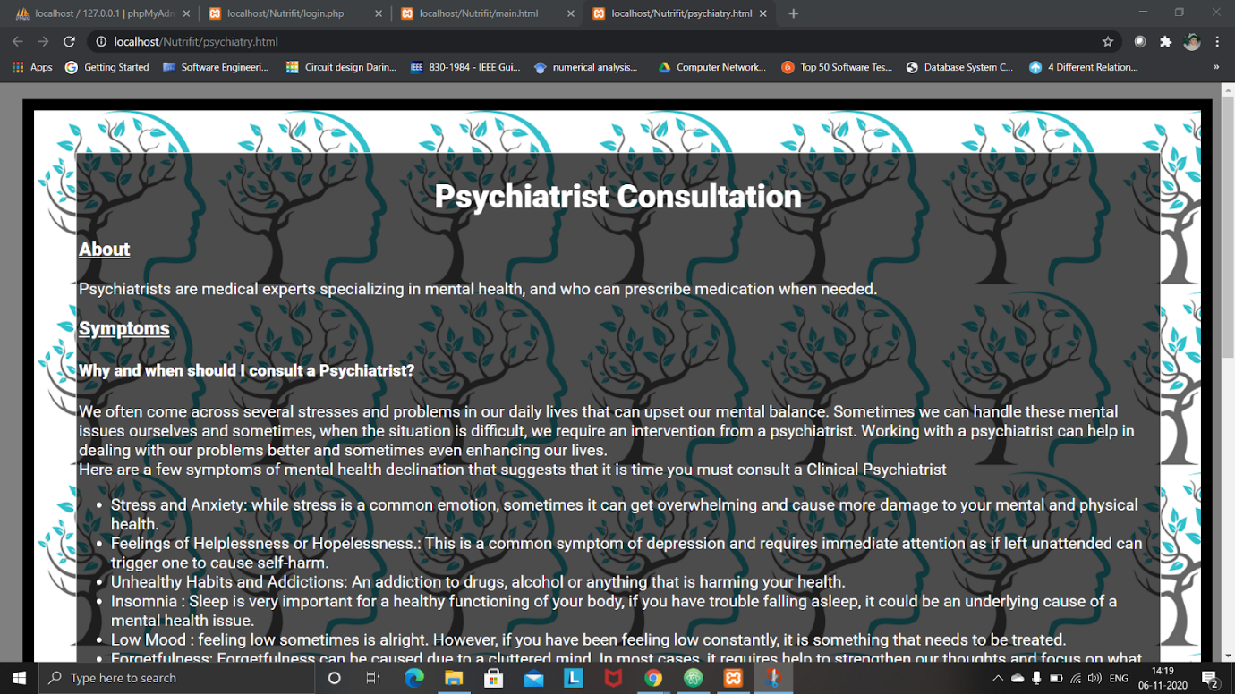

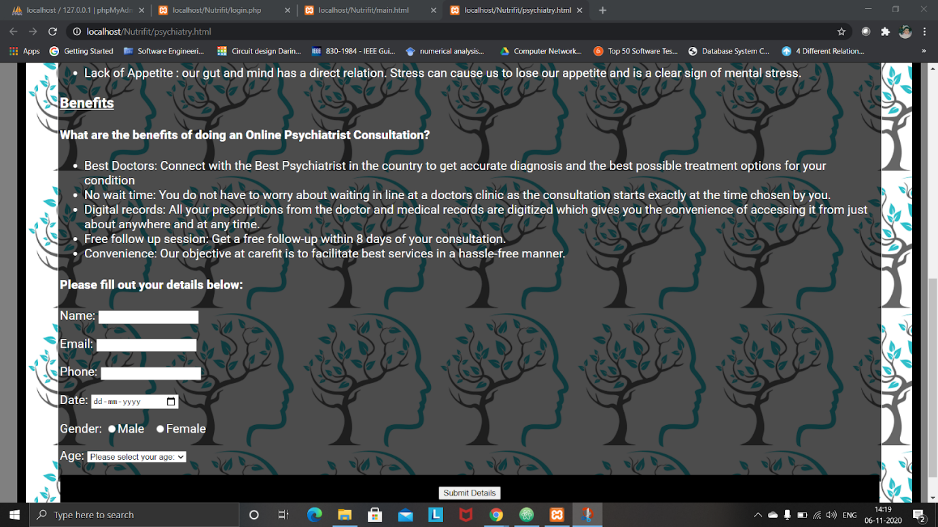

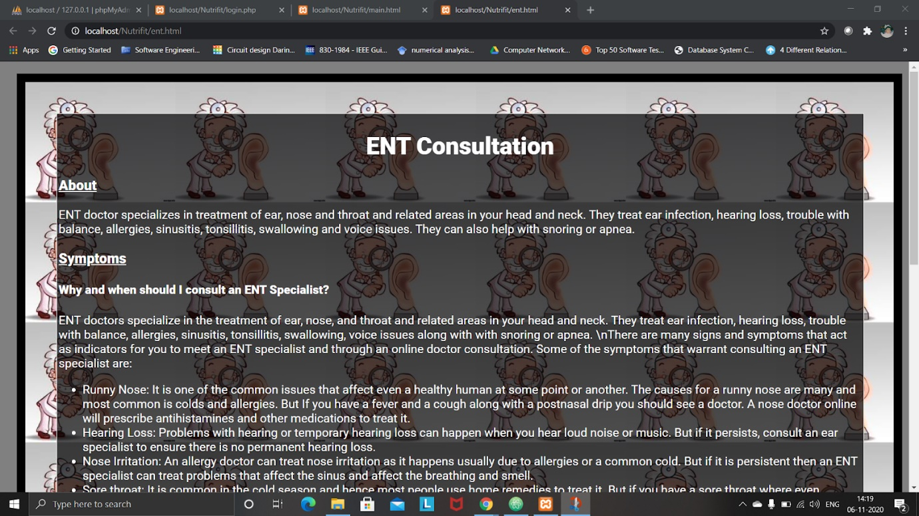

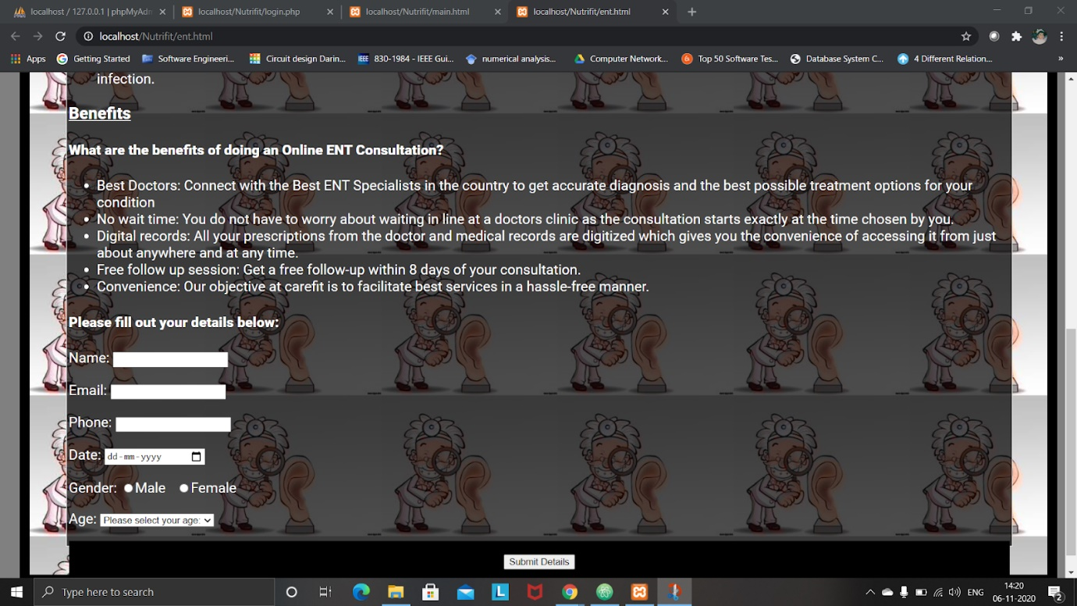

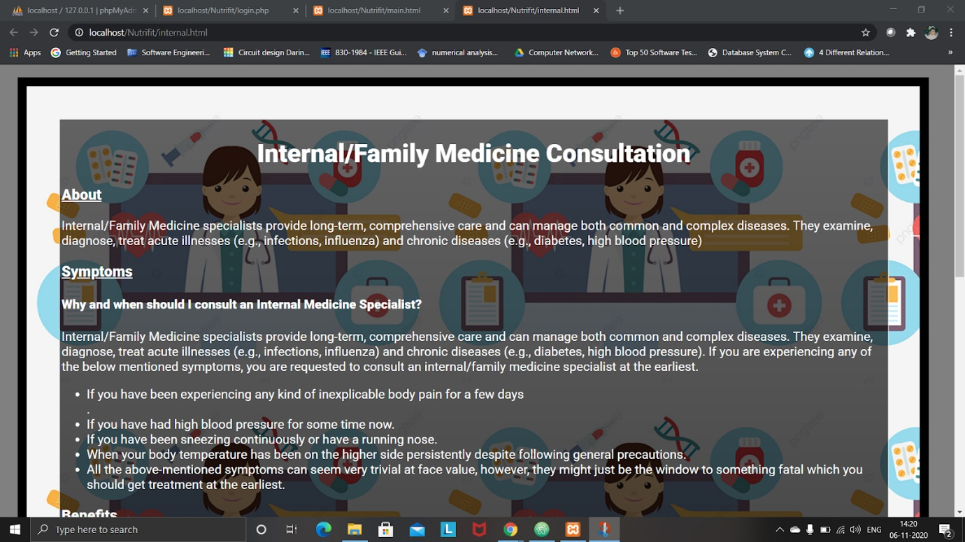

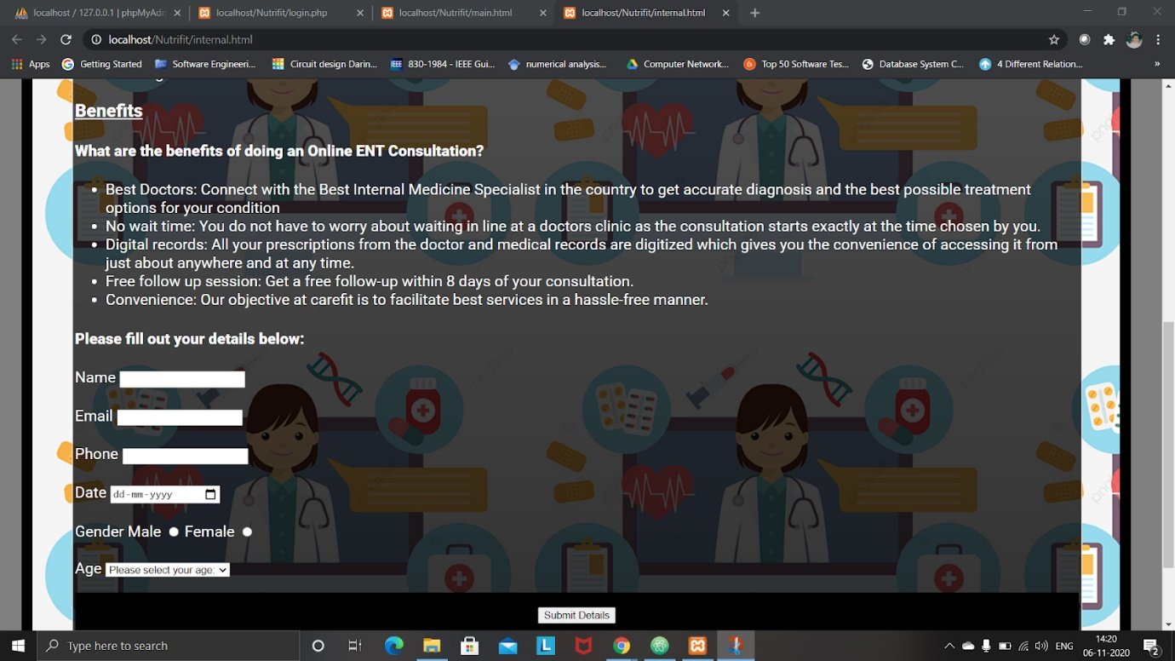

Payment

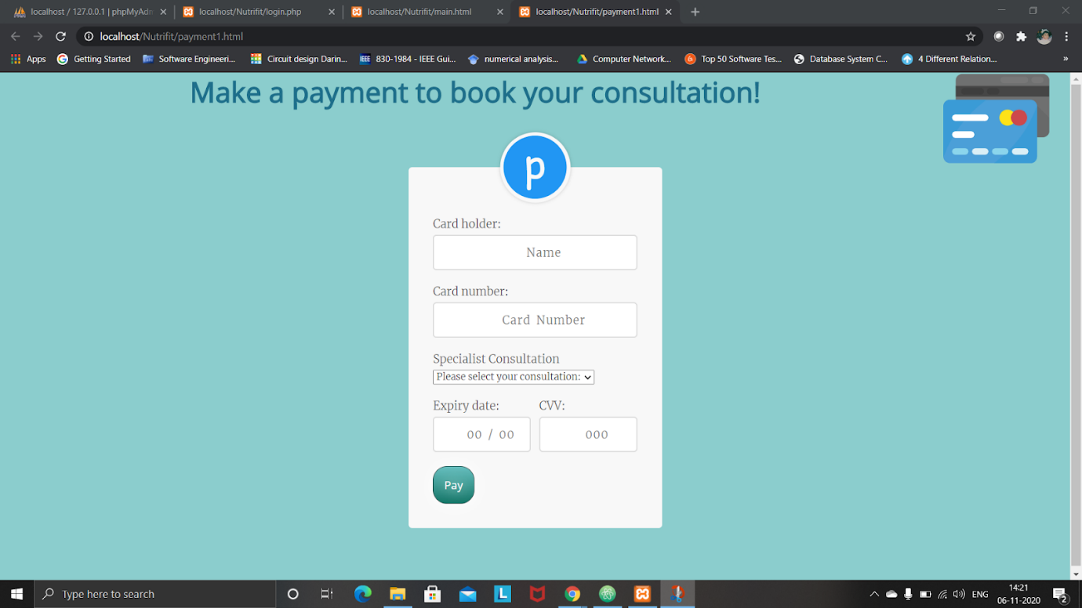

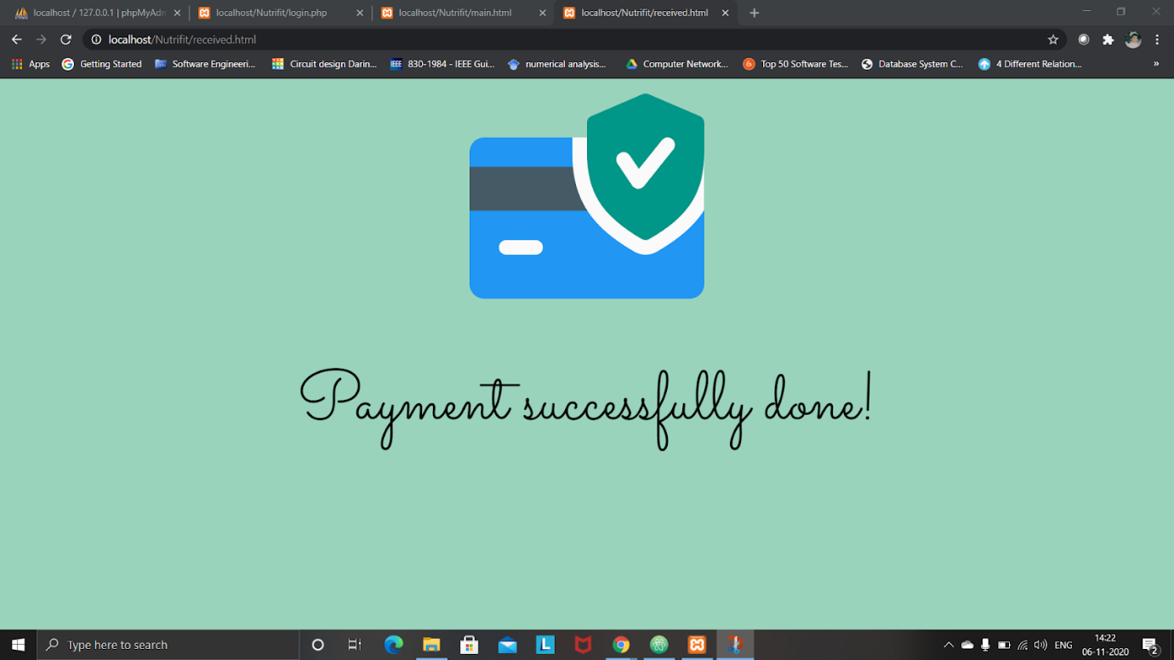

**Back End**

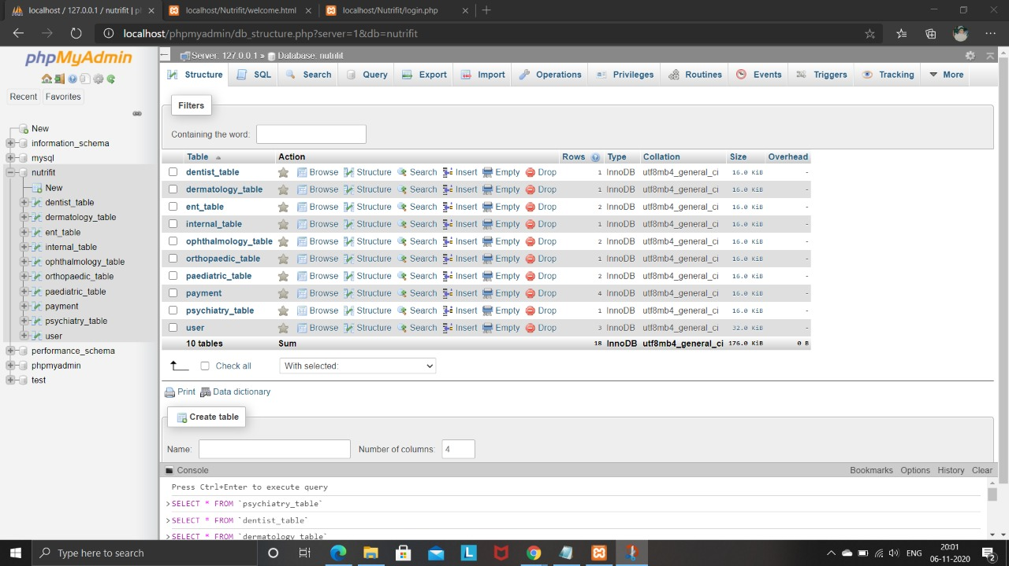

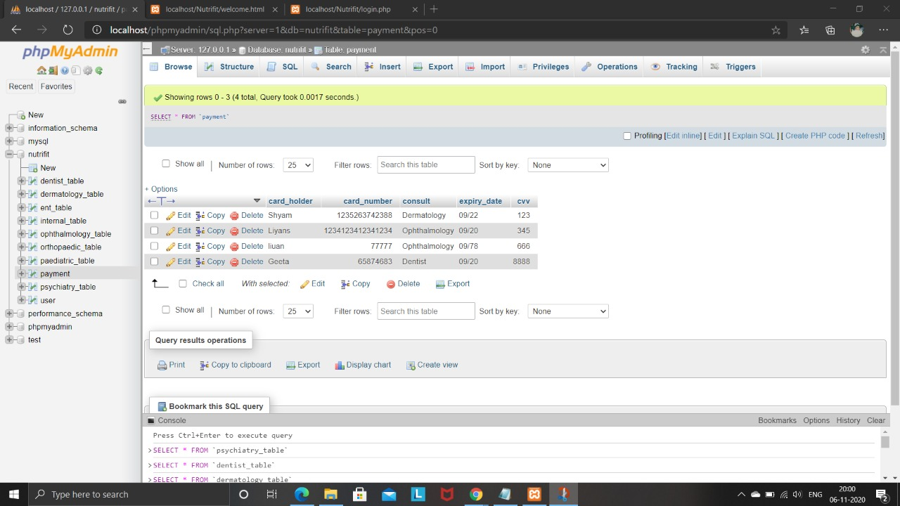

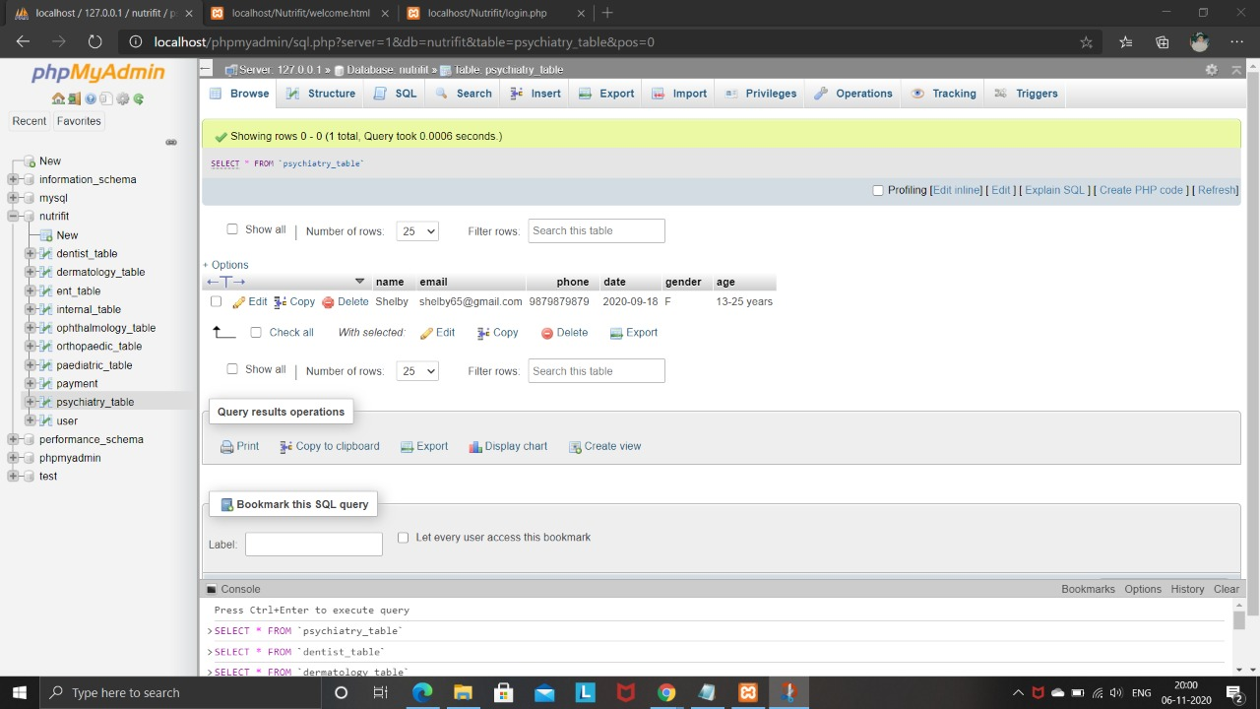

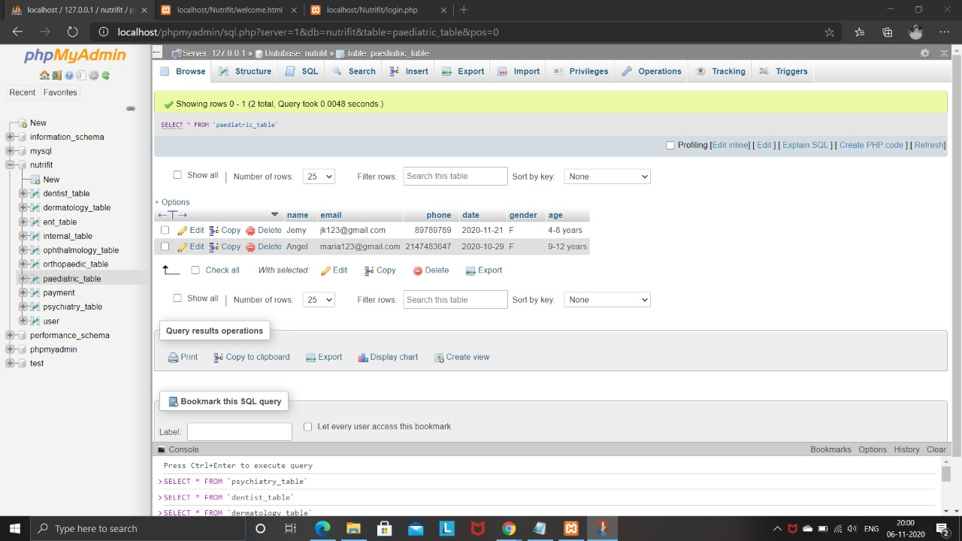

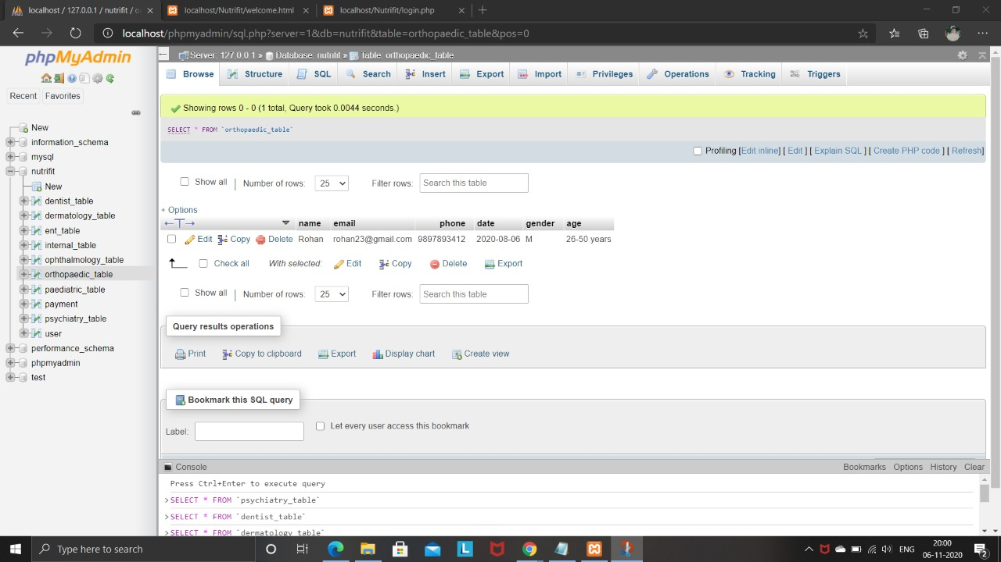

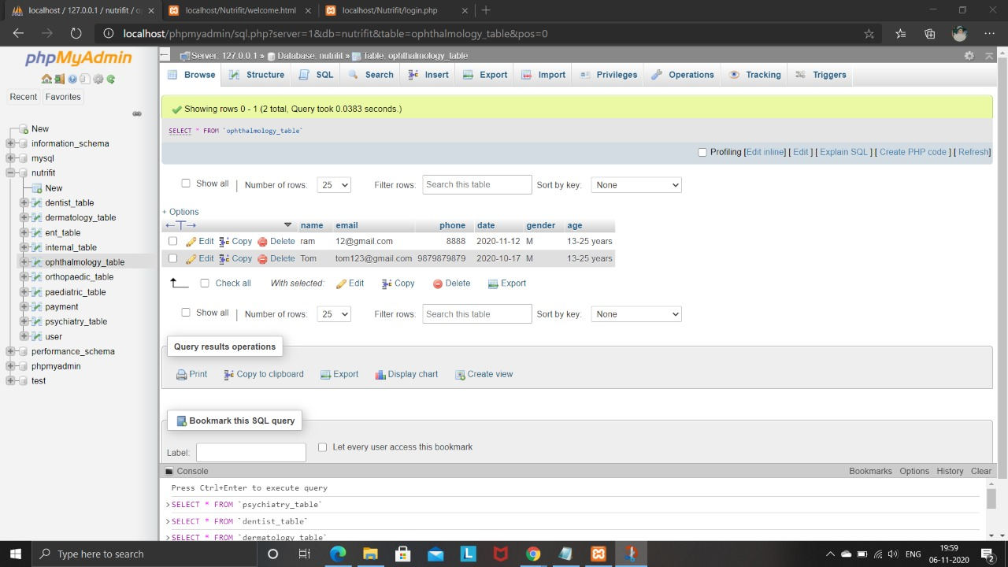

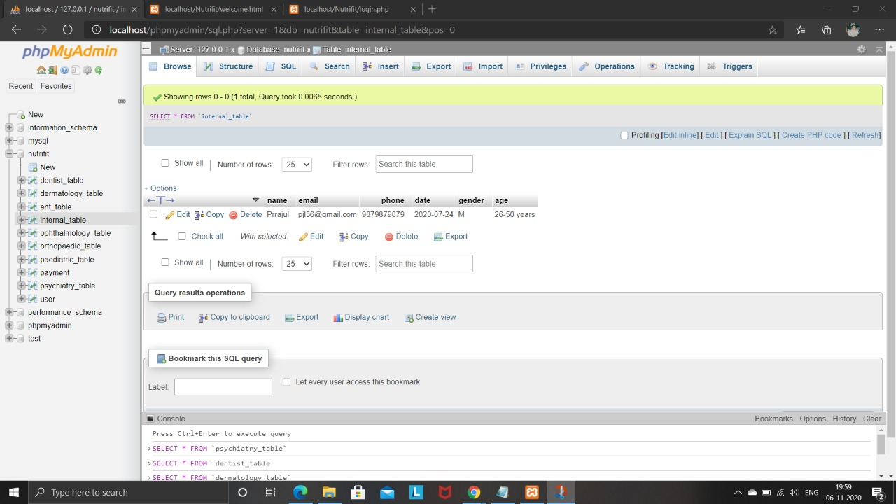

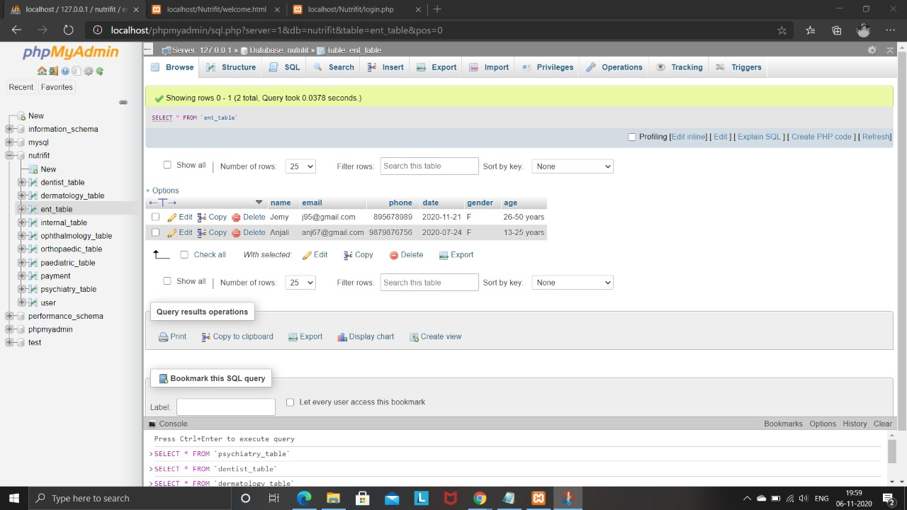

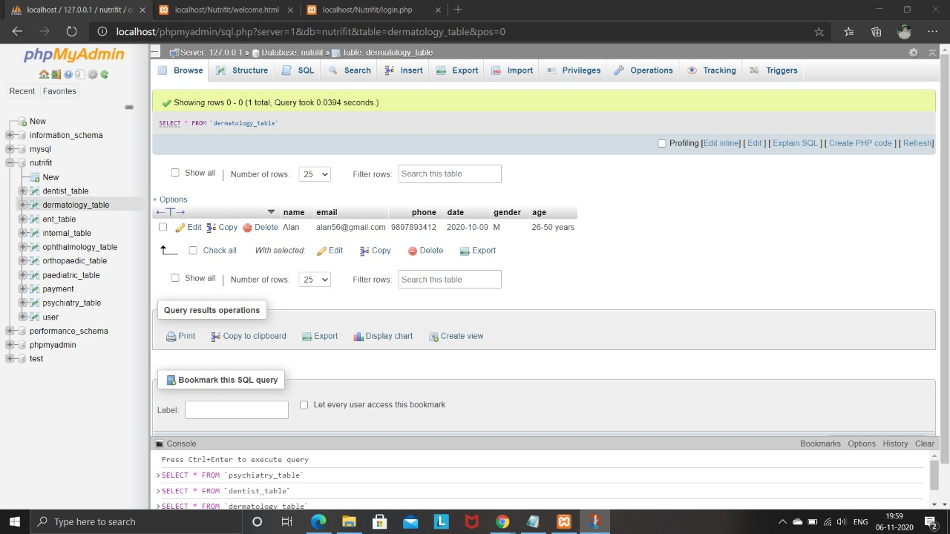

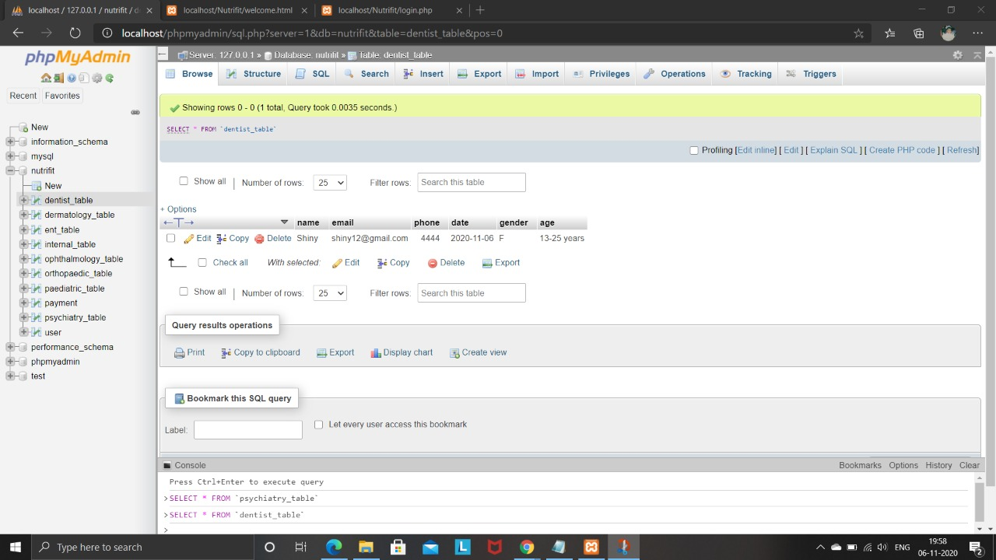

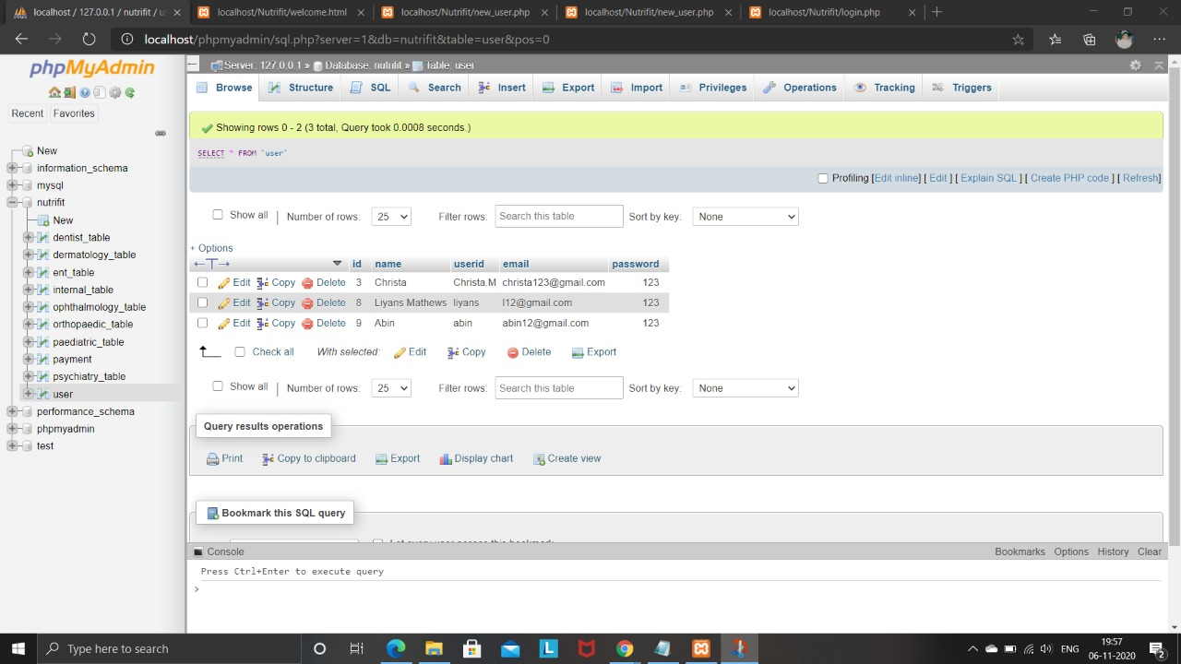

4.         DISCUSSIONS

This project uses HTML, CSS and Java Script at the front end and XAMPP with phpmyadmin (mysql) at the back end. Being a web-based project, it provides a platform for online appointment between doctor and patient and also has diet charts and workout routines needed for a healthy lifestyle.

5.         CONCLUSION

     This project is designed to help people to lead a healthy lifestyle, the different features/modules that were used is of utmost importance for the above mentioned purpose, diet chart helps in easy planning of one’s daily diet, it helps in having a fair idea of the disease that one is suffering from the basic detail page, it helps to provides different forms of exercises according to the user’s requirements and it provides an easy online appointment and consultation facility.

Thus, the various features help the user to have a fit and healthy way of living.

 6.         SCOPE OF FUTURE WORK

This website can help a long way in providing quality healthcare at the comfort of one’s home. In a world where people prefer to get everything at their doorstep, this website is a great tool when it comes to taking care of your health and ensuring you are fit and fine.

7. BIBLIOGRAPHY

* <https://www.w3schools.com/>
* <https://html.com/>
* <https://www.codecademy.com/>
* <https://www.javascript.com/>